**Path based routing using traffic manager**

The architecture that is intended to be achieved in given below:

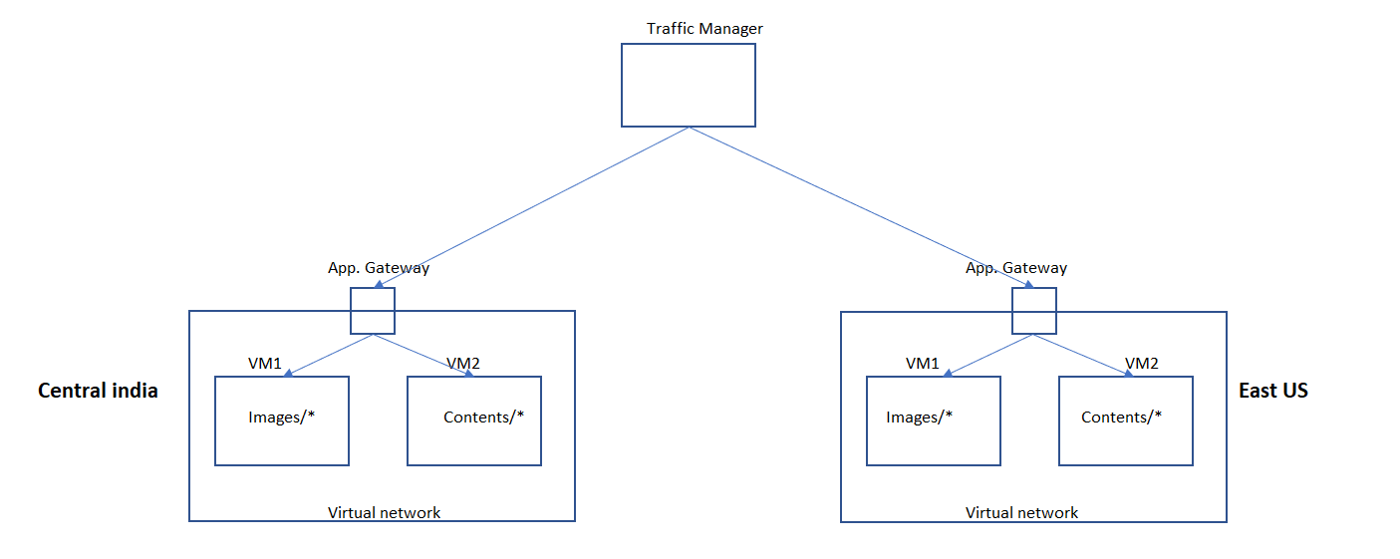

1. Create Virtual network for Central india
2. Create VM1 and VM2 in Central India within the above virtual network created
3. Create Virtual network for East US
4. Create VM1 and VM2 in East US within the above virtual network created
5. Create Application gateways for Central india & East US
   1. Configure front end IP (Set the DNS name)
   2. Configure Backend target pool
   3. Configure Listener
6. Create Traffic manager with Priority based routing
   1. Configure end points for Central india & East US gateway and for this DNS to be set for the created gateways
7. Test the connections by shuffling the priorities